RMAT Instructions

Introduction
Regular monitoring of records management, and an organisation-wide program for information governance (encompassing records, information and data), is beneficial for all public sector organisations.
Beyond a mere assessment of conformity with requirements (compliance), monitoring can actively assist organisations to embed good practices and processes. It ensures that records, information and data are managed in efficient and effective ways – to meet the business needs of the organisation, the expectations of its customers, and the requirements of Government.
Monitoring should support the organisation’s capacity to use records, information and data for decision-making, policy development and the delivery of high-quality public services. It should enable public offices to identify and manage information risks – to provide business continuity and protect the rights of all stakeholders.
Monitoring of records and information governance programs is a shared responsibility between NSW State Archives and Records (SARA) and public offices. The State Records Act 1998 places a number of requirements on public offices regarding monitoring activities. The Regulatory Framework provides further detail on assisting public offices to comply with the State Records Act and monitoring activities.

Records Management Assessment Tool (RMAT)
The Records Management Assessment Tool (RMAT) is a key part of SARA’s regulatory framework allowing:
- Public offices to self-assess and report their alignment with the regulatory framework.
- Public offices to identify areas for improvement; and possibly support a business case.
- SARA to have an overview of regulatory alignment across the sector.
- SARA to identify trends or key issues for targeted intervention, to support planning and the allocation of resources.
The RMAT enables public offices to assess the maturity of records and information management in their organisation, or a part of the organisation (e.g. business unit or information system), or a group of public offices.
The questions in this assessment are focused on the management of records, information and data in NSW public offices, and how these practices align with requirements in the State Records Act. They highlight the links between records management and regulations for cyber security, privacy, data sharing, open data and information access (GIPAA).
The results can be used for reporting on current status, planning for improvement, justifying investment, and measuring progress.

2.1 Developing the RMAT
Developing the RMAT content involved a co-design approach with staff at SARA and consultation with over 20 public offices, representing state government, local government, health organisations, and universities.
Four public offices pilot tested the RMAT and carried out assessments of their organisations and organisational units using the RMAT. The last section of these instructions includes their tips and recommendations for making the most of the RMAT.

2.2 What is the RMAT?
The RMAT is available as a WORD document or EXCEL spreadsheet. It consists of:
- Instructions for use (this document)
- A title page to collect details of the assessment
- Assessment questions
- Maturity statements (responses)
- Results statement, and
- Detailed explanatory notes and supporting guidance.
Further developments being considered include:
- the development of an online assessment tool which would enable benchmarking and comparative results, and
- guidance for public offices in responding to assessment results, i.e. the ‘next steps’.

Using the RMAT

3.1 Preparing for the Assessment
Please note that the Assessment Tool is currently available in MS Excel spreadsheet format and MS Word document format.
Choose the option that best suits your needs or preferences. The spreadsheet format includes support for automated scoring and results graphs. The document format can be more easily printed if required.
Before you begin the assessment, read through these instructions and familiarise yourself with the questions, the possible responses and the types of evidence that can indicate your level of records and information management maturity.
If necessary, review the recommended Guidance to confirm the relevant requirements.
Decide who will complete the assessment.
We recommend the person or team responsible for overseeing records and information management should answer the RMAT questions – or complete the questions collaboratively with key staff, such as a system owner, data custodian or business manager.
This is important because:
- The assessment includes some technical terms that may require explanation from a records and information professional. Perhaps you use different or specific terms in your organisation. You can also refer to the SARA Glossary for definitions.
- Some questions may be more applicable at the organisation-level (e.g. if there is a central policy or executive leadership). You could consider pre-filling the answers to these questions before asking a system owner, data custodian or business manager to complete other questions.
- It builds awareness and communication between the business and the person or team responsible for overseeing records and information management. For example: the SRO must have visibility of records and information management in all parts of the business, in order to fulfil their responsibilities; business managers should be aware of corporate-wide policies.
- It enables the person or team responsible for overseeing records and information management to better appreciate the ecosystem of records, information and data; and how well it is supporting business needs.
- It enables the person or team responsible for overseeing records and information management to fully understand the level of maturity in their public office, plan for improvements and justify requests for resourcing.
The assessment should not just be a one-time or annual activity. Public offices can use the RMAT frequently throughout the year.
You don’t have to assess the whole organisation to make use of the RMAT. You could focus your assessment on one (or several) business units or information systems.
Perhaps there is an area you have been wanting to assess – either because you think it is doing well or because you think it may need improvement.
Examples of events that might act as the catalyst for a maturity assessment, or when results may be useful include:
- Internal or external audit exercises
- Cyber security attestation
- Privacy Impact Assessment
- GIPAA review or investigation
- Developing a Data Sharing Agreement
- Annual or quarterly management reporting
- Work planning and budgeting
- Workforce capability planning
- Training needs analysis
- Staff development plans
- Organisation restructure or machinery of government (MOG) changes
- Digital initiatives to procure, decommission, or upgrade systems
- Measuring and reporting the impact of an IT or information management project.
- Formal request from SARA for information on the organisation’s records and information management practices and conformity with requirements.

3.2 Assessment Details
Start with the second tab called “Title Page” in the MS Excel spreadsheet; or the first page of the MS Word document.
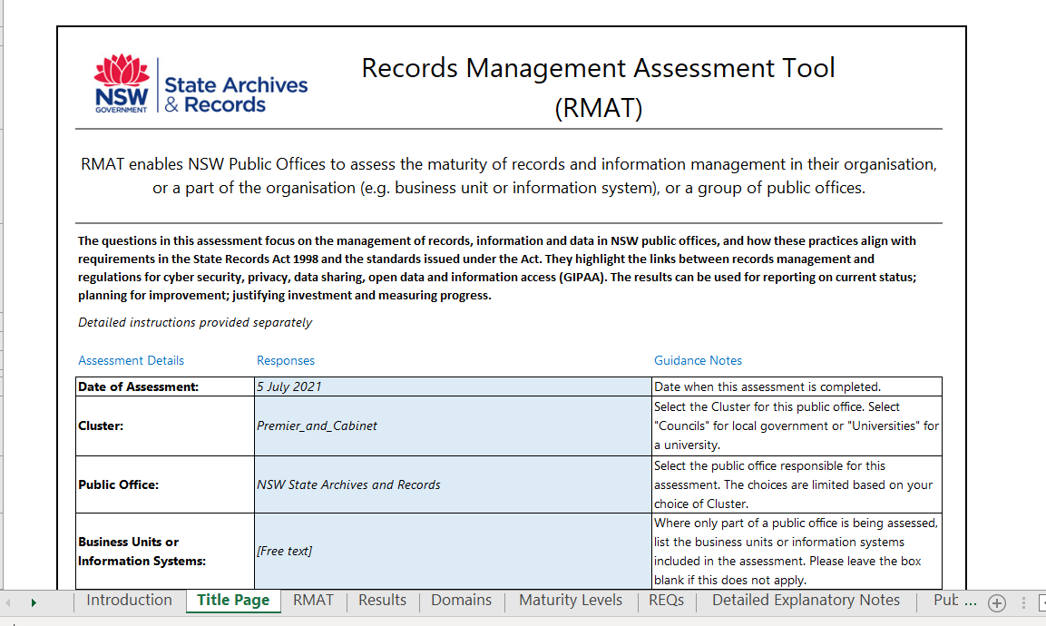
In the MS Excel spreadsheet, you can choose your Cluster and Public Office from the drop-down lists.
The other fields in the MS Excel spreadsheet are all free-text for you to enter the relevant details.
Fill out the details of when, by whom and how the assessment is being carried out.
We recommend the questions should be completed by the person or team responsible for overseeing records and information management, as described in section 1. Preparing for the Assessment (above).

3.3 Completing the RMAT Questions
Move to the third tab called “RMAT” in the MS Excel spreadsheet; or the next page of the MS Word document, where you will find the first question.
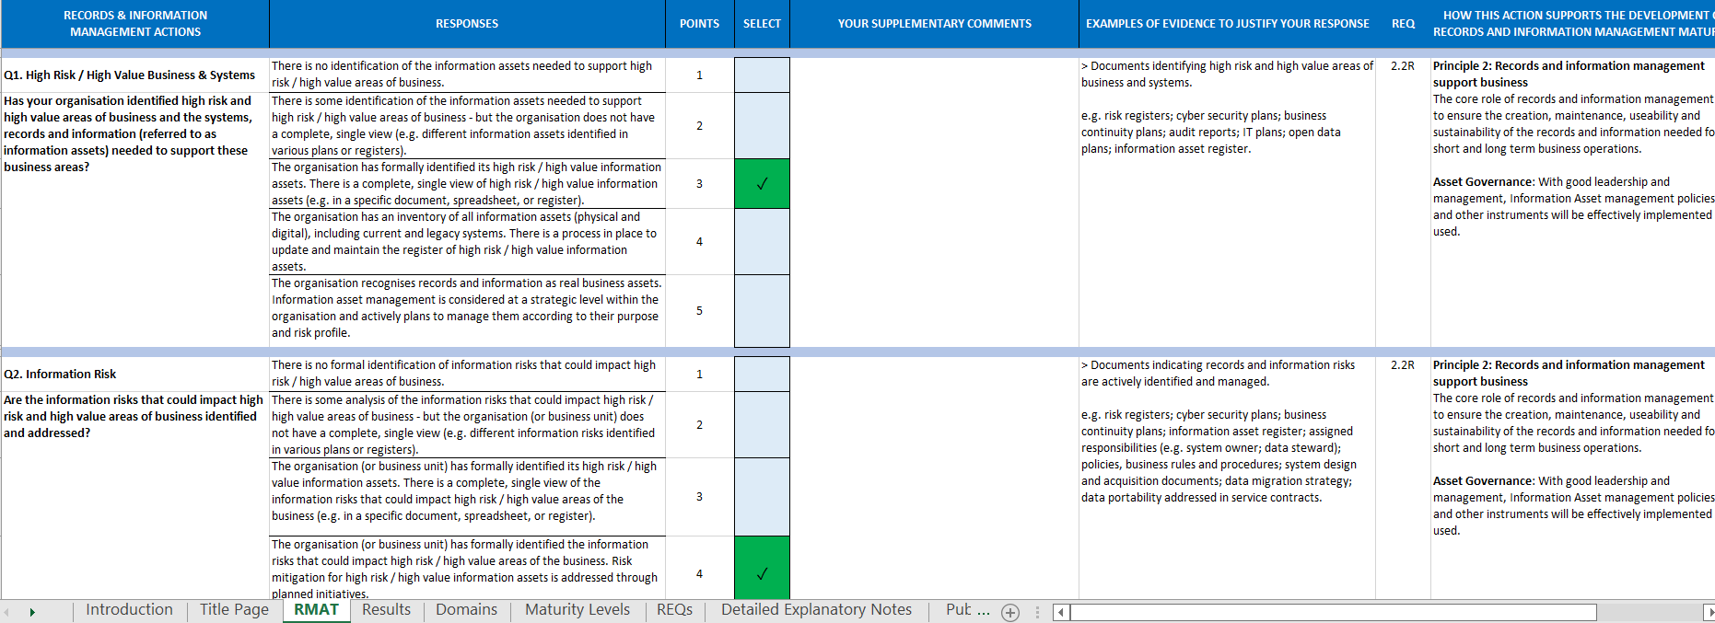

Column Headings
The sheet contains the following columns:
- Records & Information Management Actions – there are 19 questions to be answered.
- Responses – each question offers a choice of 5 possible responses.
- Points – value of each response.
- Select – click in the box to choose only one response.
- Examples of Evidence to Justify Your Response – drawn from SARA guidance.
- Req. – which regulatory requirements are linked to this question. (See REQs tab for full text.)
- R indicates a requirement from the Standard on Records Management
- S indicates a requirement from the Standard on Physical Storage
- SRA indicates a requirement from the State Records Act 1998
- How this action supports the development of records and information management maturity – principles from SARA standards, and the information domains that explain how achieving maturity in one area of records and information management can support further development across the organisation.
- Key guidance about this topic – drawn from SARA guidance.
- Links to locate the guidance online.
The eighth Tab called Detailed Explanatory Notes in the MS Excel spreadsheet; or the final section of the MS Word document has more detailed explanatory notes; more examples of evidence to justify your responses; and more SARA guidance resources.

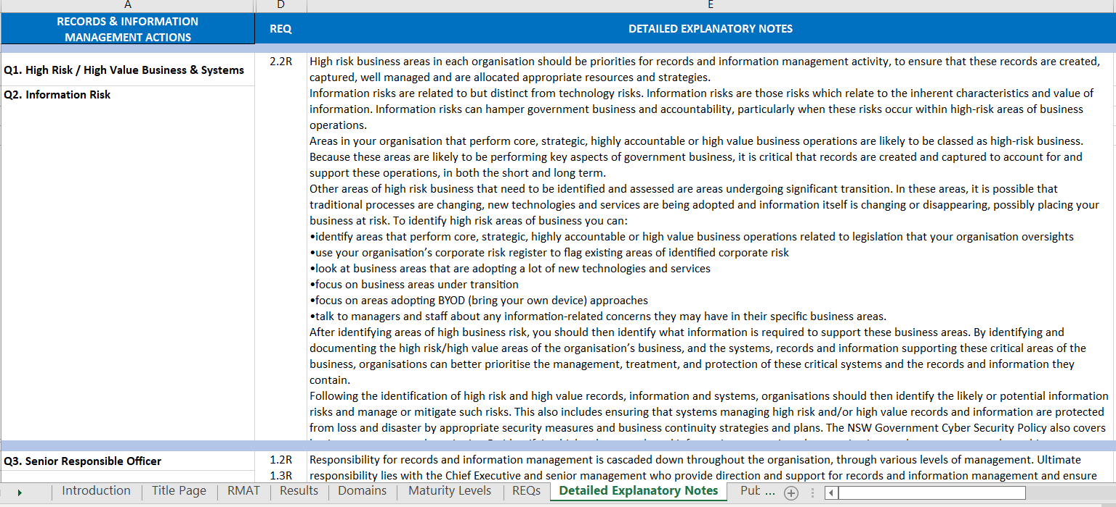

Answering the Questions
The questions in the RMAT focus on the records and information management maturity of NSW public offices, and their alignment with the requirement of the State Records Act 1998.

Question 1: High risk / high value areas of business and systems
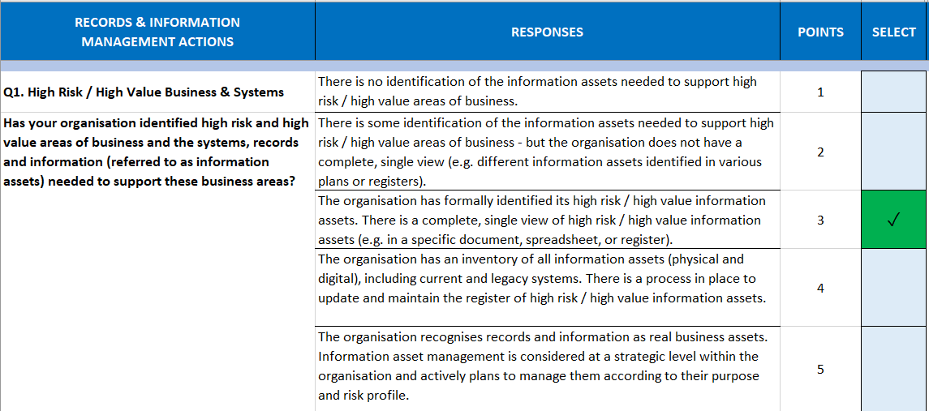
Question 1 considers the most important action for meeting Baseline Compliance. If you have not formally identified high risk / high value areas of business and systems, it may be difficult to demonstrate that appropriate controls have been implemented for critical information.
As a starting point, you will need an agreed list of high risk / high value activities or systems for the organisation or business unit being assessed.
If the person or team responsible for records and information management does not have relevant documentation, you can check with colleagues in ICT, Security, Governance, Corporate, Risk or Legal to find out if this analysis has been carried out for another purpose.
High risk and high value areas of business and systems may be identified during:
- Cyber security attestation or information security planning
- Business continuity and disaster recovery planning
- Corporate risk management (risk registers and plans)
- Responses to audit, inquiries or litigation
- Systems audit or IT asset inventory
- Information lifecycle management planning
- Open data planning and reporting
- Development of a retention and disposal authority.
Once you have an agreed list, it will be possible to identify records and information relating to those activities – and plan to address them.

Choosing a response
For each question, choose only one response which best describes your current situation. Please note that the MS Excel spreadsheet and MS Word document will allow the selection of more than one response.
If you choose a response and then change your mind you must “de-select” the non-applicable rating.
The response will depend on whether you are assessing a business unit, system or the whole organisation. For example: some systems vs High Risk/High Value vs all systems. Make sure this is clear on the Title Page, so you know which systems are included in the scope of the response.

Considering the evidence
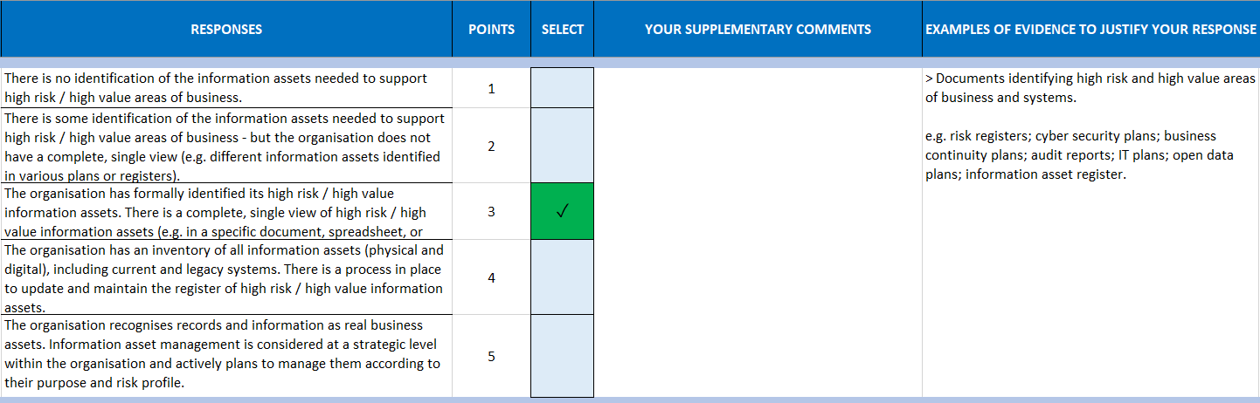
Look at the types of evidence required to demonstrate this level of maturity in the Examples of Evidence column, and ensure you can justify the response you’ve chosen.
You may have other types of evidence that are not listed in the Examples of Evidence column.
The evidence you choose does not impact the assessment results. It is a summary of the kinds of information you took into consideration when selecting your response.
You may have to provide or describe the relevant evidence to your executive or Senior Responsible Officer, if the assessment is being carried out for internal planning, reporting or auditing.
You may be asked to provide or describe the evidence to SARA, if the assessment is being carried out for a regulatory purpose.
A lack of evidence will usually indicate a lower level of maturity.
Don’t spend “too much” time searching for evidence. If it takes more than 20 minutes to identify the evidence, consider selecting the lowest level of maturity, indicating the organisation or SRO is unaware of whether a requirement is met.
If you feel you are “between two levels”, you must select the “lower” level – i.e. the level for which you have evidence to show it’s fully met.
Refer to some of the Guidance material if you need more help understanding the requirements, or considering your next steps to improve maturity in this area.

Your supplementary comments
Use this space for your own notes about each question. For example: if your discussions highlighted gaps and potential corrective actions; stakeholders who were consulted in relation to that question; notes about the evidence you have identified to justify your response to the question or challenges identifying suitable evidence. This information is for your own internal planning and development purposes.

3.4 Reading the RMAT Results
Move to the fourth tab called Results.
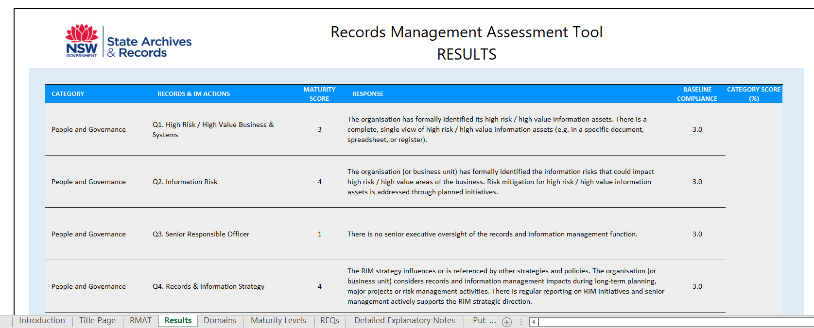

If your results appear incorrectly (e.g. over 100%) or indicate an error – remember to check that you have selected only one response for each question.

Baseline Compliance
A maturity score of 3 is considered Baseline Compliance – meeting SARA’s requirements for high risk / high value records and information.

Maturity Score – Table 1
The first table (example above and below) shows the Maturity Score for each question, based on the response provided.
The maturity levels are described on the last page of this document.
Questions have been grouped into three themes or categories for a broader view of results:
- People & Governance (PG)
- Systems & Business (SB)
- Information Management (IM)
The % result is calculated by the sum of scores for questions in a Category, divided by the total possible score for that Category. Weighting has not been applied to any of the questions.
The diagram below shows the % result for the Systems and Business category.
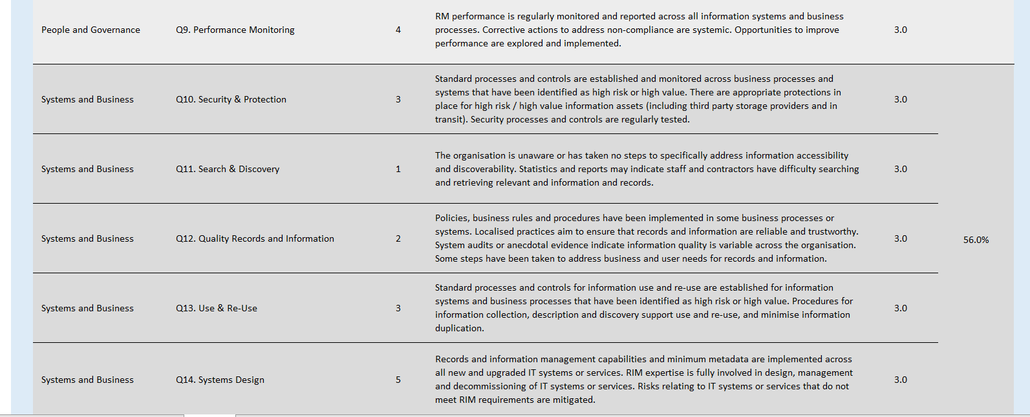

Traffic light report – Table 2
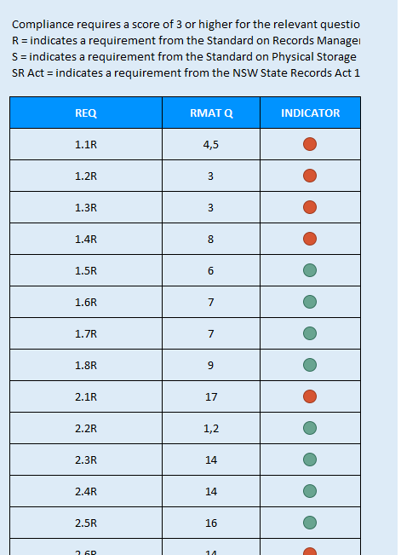
The second table cross-references the regulatory requirements with the RMAT questions and indicates whether compliance is demonstrated for each requirement. The indicator is Green when the relevant question has a score of 3 or higher. For a score less than 3, the indicator is Red.
Where a requirement is linked to two questions, the indicator is Green when both questions have a score of 3 or higher.

Graphs
The Results tab also includes two graphs that present the maturity scores visually.

Using the Assessment Results
The RMAT is a key part of SARA’s new regulatory framework allowing:
- Public offices to self-assess and report their alignment with the regulatory framework.
- Public offices to identify areas for improvement; and possibly support a business case.
- SARA to have an overview of regulatory alignment across the sector.
- SARA to identify trends or key issues for targeted intervention, to support planning and the allocation of resources.
Public offices can use the results of an assessment for reporting on the current status of their information governance programs; planning for improvement in a particular business unit or information system; justifying investment and measuring progress.
Assessment results can also support planning and reporting for cyber security, privacy, data sharing, open data and information access (GIPAA).
Refer to the earlier section of this document (Preparing for the Assessment) for a list of events that could make use of the assessment results and might act as the catalyst for a maturity assessment.
In order for SARA to effectively regulate and respond to emerging issues, risks and challenges, and measure improvements in performance over time, we need to have a clear view of how well public offices are performing against the records management requirements established in the State Records Act and the standards issued under the Act. Monitoring activities provide this view of performance. We are planning a new formal reporting process using the public office’s RMAT assessment, whereby public offices confirm that the records management program, policies, internal controls and processes are in place.

4.1 Next Steps
When planning “next steps” from these results, the following suggestions may be helpful:
- Consider Question 1 and ensure you have a clear view of high risk / high value records and information
- Review the questions with a maturity score less than 3. Consider:
- which ones may relate to key strategic priorities for your organisation?
- what is “missing” in order to reach the next stage of maturity?
- which requirements is the question aiming to address?
- read the relevant SARA guidance for more help with each question.
- Look for any trends or themes. For example, is there a strength or weakness across a particular Category?

Information Domains
Consider the Information Domains on the fifth Tab in the MS Excel spreadsheet; or the next section of the MS Word document.
These can help articulate how achieving maturity in one area of records and information management can support further development across the organisation – towards an environment where investment in the quality of information assets is driven by business benefits and value, rather than IT costs and efficiencies.
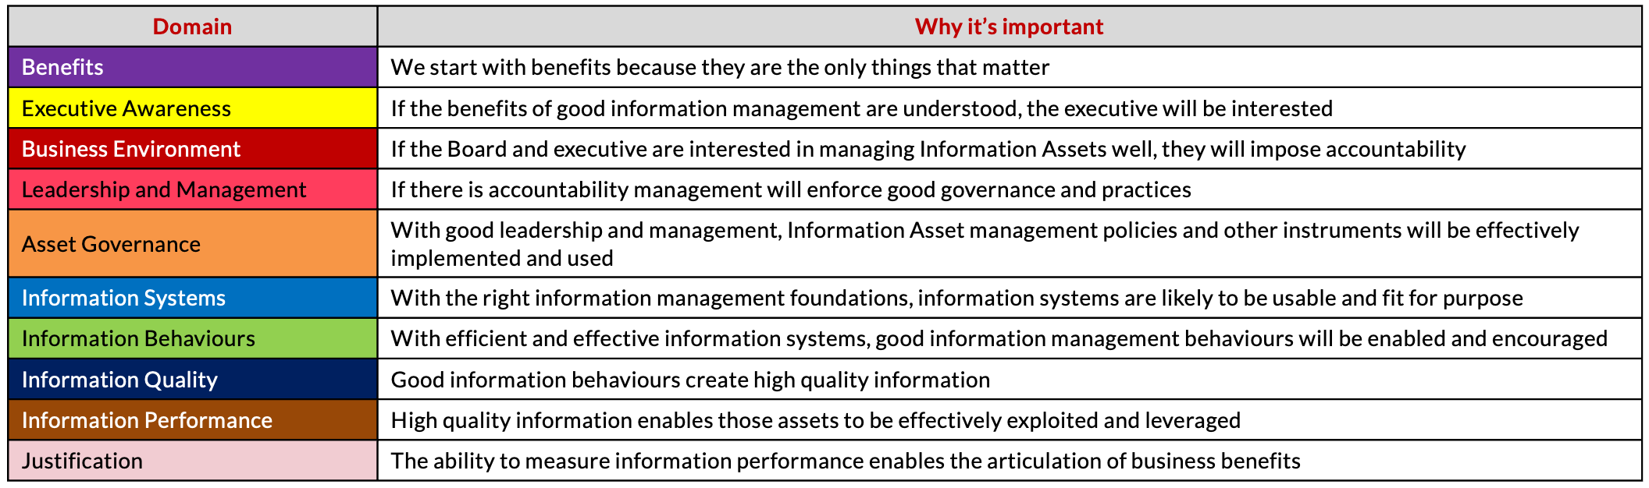

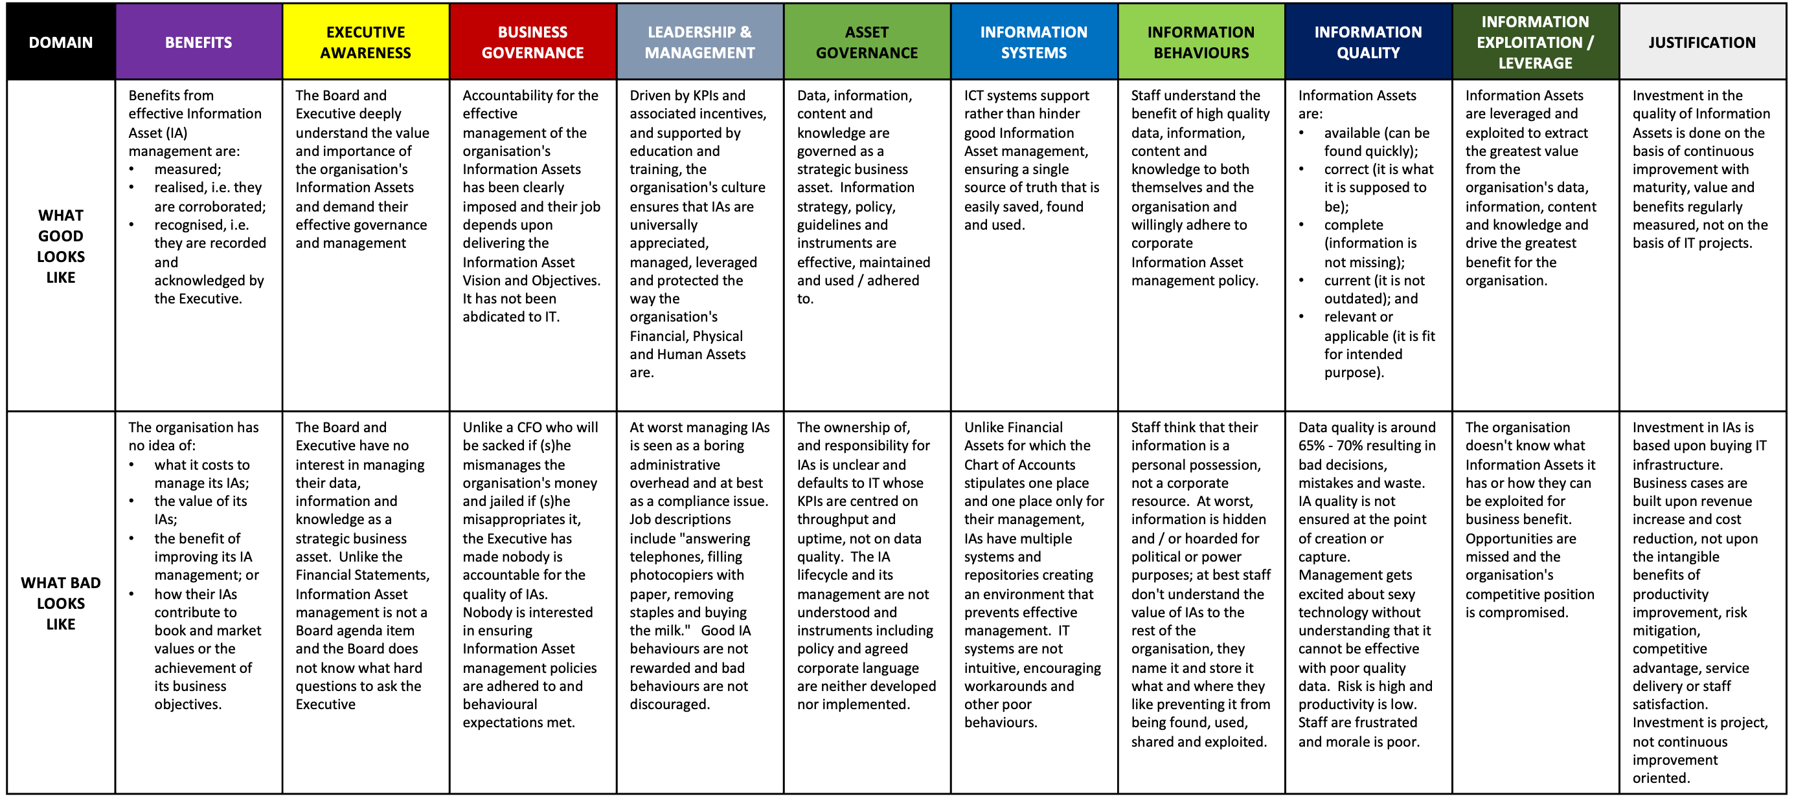

The information in these tables is Commercial in Confidence and Copyright © Experience Matters Pty Ltd. 2021

Maturity Levels
The Maturity Levels are also included in the sixth tab in the MS Excel spreadsheet; or the next section of the MS Word document.
1 | Initial | The desirable processes are non-existent or ad hoc, with no organisational oversight. The organisation or senior responsible officer is unaware of whether a requirement is met.
1 | Initial | - Ad hoc, unpredictable, poorly controlled, no processes, unaware.
2 | Developing | Processes are becoming refined and repeatable, but only within the scope of individual teams or projects. There are no organisational standards.
2 | Developing | - Aware, reactive, repeatable, documented processes.
Level 3 is considered Baseline Compliance
– meeting SARA requirements for high risk / high value records and information.

3 | Defined | Processes are standardised within the organisation based on best practices identified internally or from external sources. Knowledge and best practices start to be shared internally.
3 | Defined | - Controlled, established, standardised, followed processes.
4 | Managed | The organisation has widely adopted the standard processes and begins monitoring them using defined metrics.
4 | Managed | - Capable, proactive, measured and reported.
5 | Optimising | The organisation is optimising, refining and using innovation to increase efficiency within the organisation and, more widely, within its business sector.
5 | Optimising | - Efficient, reviewed and audited, data-driven process improvement.

Tips and recommendations for use
During the content development project, four public offices carried out assessments using the RMAT. This section provides some of their tips and recommendations for making the most of the maturity assessment.

How much time does it take?
Take some time before you start, to read through the questions and responses and be familiar with the content.
Allow an hour to factor in the evidence and additional guidance to make preliminary responses.
We brought together a team of experts from different professional disciplines. They each completed an assessment of the organisation. We then held 2 x two-hour workshops to discuss the individual responses to each question and settled on a score for each question. This process gave us the overview of the organisation’s maturity, but to fully complete the RMAT with comments and links to documents/evidence would require several more hours.
Allow sufficient time to discuss the answers to the questions. It’s a process that should take some days rather than minutes/hours to properly finalise the assessment.

Things to be aware of
A business unit heavily relying on shared drives and SharePoint to keep records might consider themselves Level 4, but the records team might rate them as Level 2.
Prior to sending the RMAT to staff in a business unit, prefill certain questions and consider what technical terms would need some explanation.
Recommend that the Records Management/Information Management team does the assessment in collaboration with the business unit. The RMAT assessment is a great way of commencing discussions on business needs and expectations of good records management, and how the Records Management/Information Management team can assist the business.
Completing some questions in the RMAT requires a high level of records management knowledge. In particular, respondents will need to have an organisational perspective on how aspects of records management are conducted across the organisation, including information security and cloud use.

Suggestions for use
Don’t just use the tool “once” to get the results. The RMAT should become part of the regular monitoring and reviewing processes for the organisation.
Use the RMAT for doing a SWOT analysis of the records and information services.
Internal auditors will find that the RMAT useful in assessing the threats/weakness in the records and information services in the organisation.
The RMAT is well suited for doing separate analysis of how smaller business units within an organisation are performing and meeting organisational requirements and those of the State Records Act.
The results are meaningful in that they clearly identify areas for improvement and information to aid a business case. The results can be used as a conversation piece to assist with requesting assistance/resourcing to improve.
The RMAT is a useful conversation starter between the records and information team and staff in the business units. It’s a great way to find out what is happening on the ground and raise awareness of policies, responsibilities and the services that the records and information team provide.
Organise a team of professionals from across the records and information management services and business units to complete the assessment, compare and discuss/debate the results. While it may skew the results in different ways in the discussions, this approach enables a richer view of the organisation’s maturity and capability.
The RMAT also helps to determine if records and information management services meet the expectations of internal customers and if there is more that can be done to support the organisation’s needs for information.

